M E M O R A N D U M

TO: Sybile Cherenfant
1673 Edmund Terrace
Union, NJ 07083

FROM: Frederick G. Kohun, Ph.D. 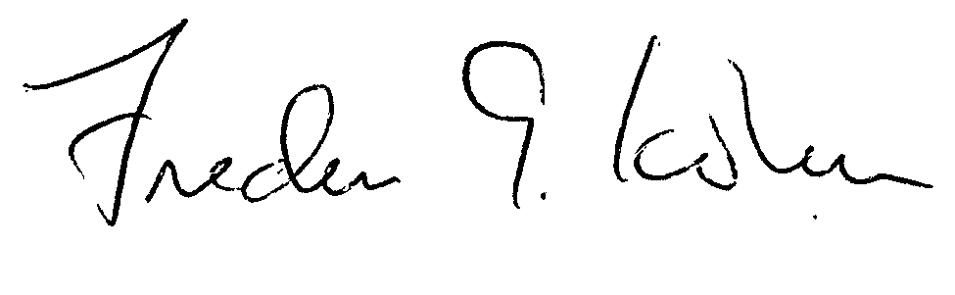
Chair, Institutional Review Board
Robert Morris University

DATE: January 3, 2012

SUBJECT: IRB#111201 – Gender Preferences in Classroom Aesthetics

The above-referenced protocol has been approved through an expedited review procedure by the Institutional Review Board. This protocol meets all the necessary requirements and is hereby designated as exempt under section 45 CFR 46.101 (b)( 2). Expedited protocols are approved for a period of three years. If you wish to continue the research after that time, a new application must be submitted.

Approval Date: January 3, 2012

Expiration Date: January 3, 2015

Please know that this IRB will be closed in the IRB database after 3 years.

cc: Dr. Philip Harold
Dr. Monica VanDieren

/kme

